- Which are the 2 main API styles?
  - REST
  - Procedure Oriented
  - Entity Oriented
  - Graph
- What is the shared responsability model?
  - A model describing the responsability of the cloud and the customer with regards of security
  - A requirement for the ISO 27001 standard
  - A model describing the responsability within a development team
  - A framework for finding out the optimal security approach
- Which of the following represent types of load balancers?
  - NAT
  - HTTP
  - DNS
  - TCP/PPD
- Related to user access and permissions for infrastructure security, confidentiality enforces
  - usage of password vaults
  - two factor authentication
  - saving data only in private clouds
  - encryption
- Monitoring of the virtual host is useful to ensure:
  - knowing your curent price to pay
  - knowing when to scale (up/down, in/out)
  - knowing the size of the database
  - if provider respects contracts (SLA)
- Which of the following characteristics is improved by designing and building applications in cloud enviroments?
  - Control
  - Scalability
  - Availability
  - Security
- FaaS stands for
  - Functions as a service
  - Functionality as a service
  - Frontend as a service
- In a cloud environment the role of a load balancer is to:
  - balance traffic across multiple targets
  - A/B testing
  - serve as a single point of entry
  - monitor the health of target resources

- Among the techniques for achieving high availability are:
  - floating/elastic IP
  - multi region
  - real time operating system
  - multi availability zones
- What makes a system highly available?
  - data
  - software
  - hardware
  - network
- Infrastructure security is concerned with
  - cloud user
  - database user
  - operating system user
  - application user
- What of the following components are not managed by the cloud provider in a infrastructure as a Service model?
  - Storage
  - Network
  - Operating system
  - Application
  - Data
- Which are the two effective measures to improve infrastructure security?
  - Implement OAuth 2.0
  - MFA for the users
  - MFA for the development team
  - Reduce the attack surface as much as possible
- How are the messages retrieved from queues in comparison to pub/sub systems?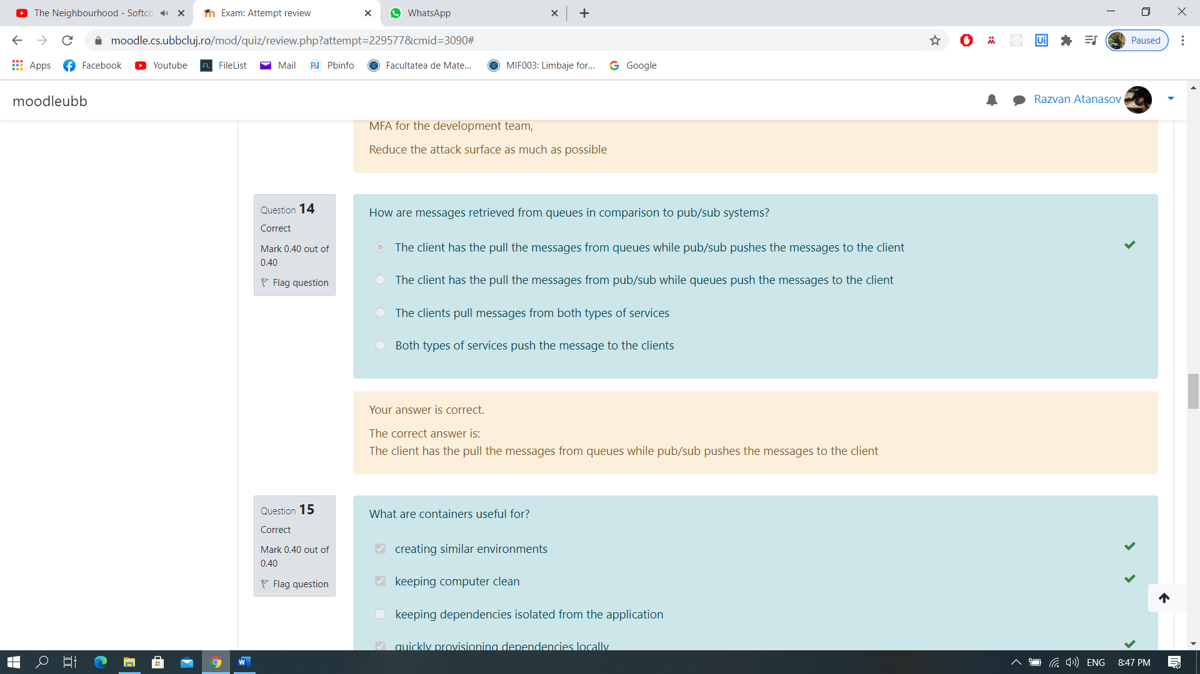
- What are containers useful for?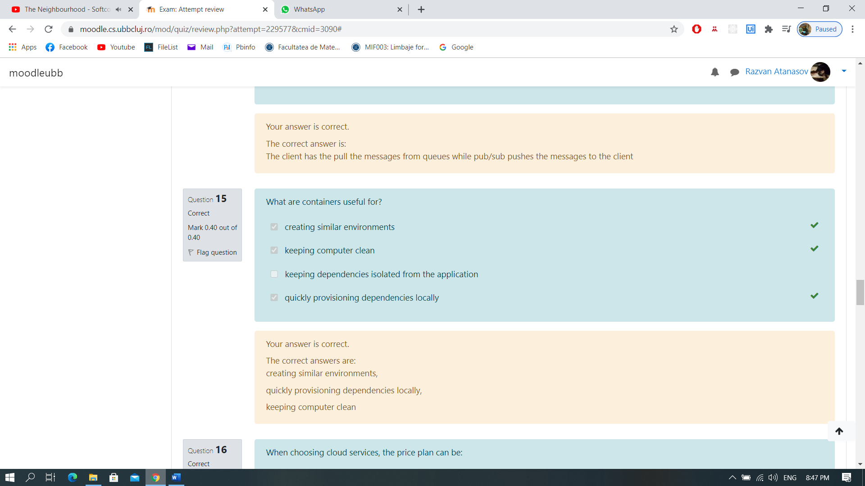
- When choosing cloud services, the price plan can be: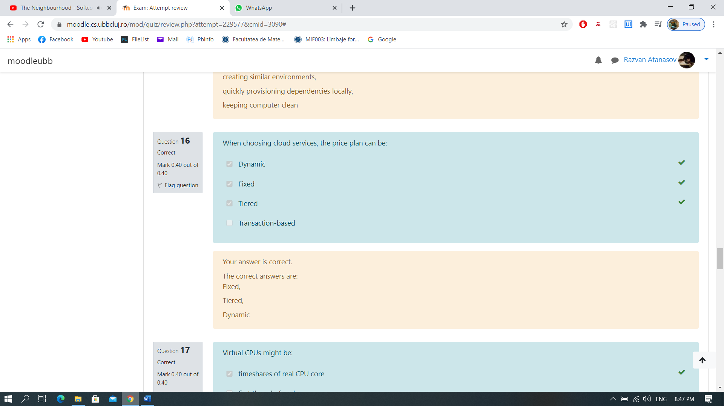
- Virtual CPUs might be: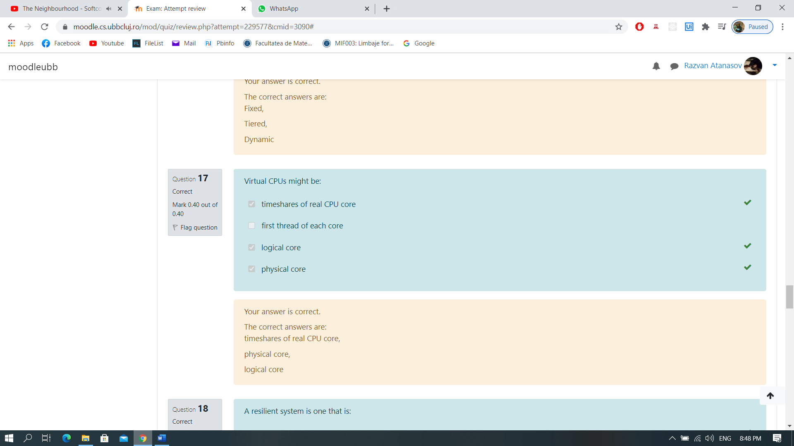
- A resilient system is one that is: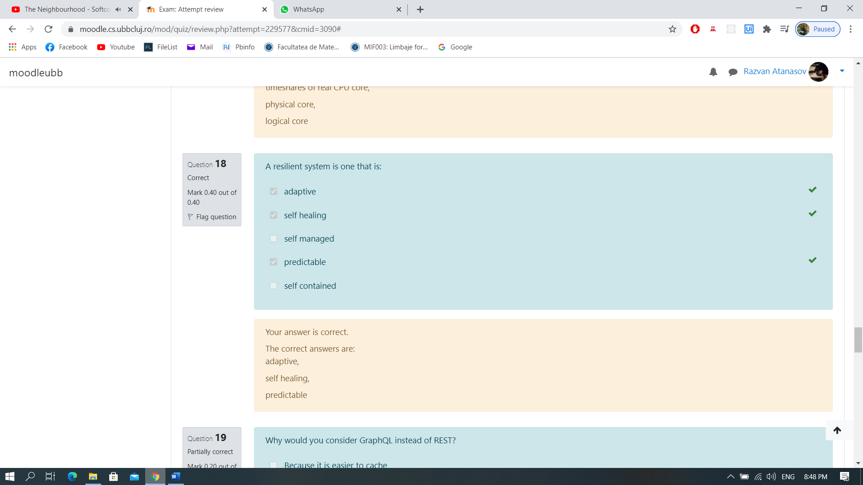
- Why would you consider GraphQL instead of REST?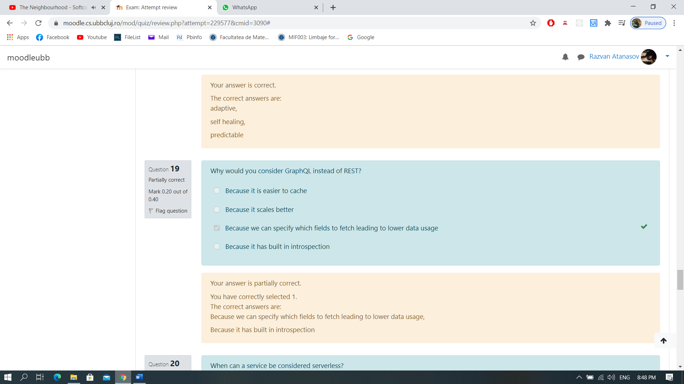
- When can a service be considered serverless?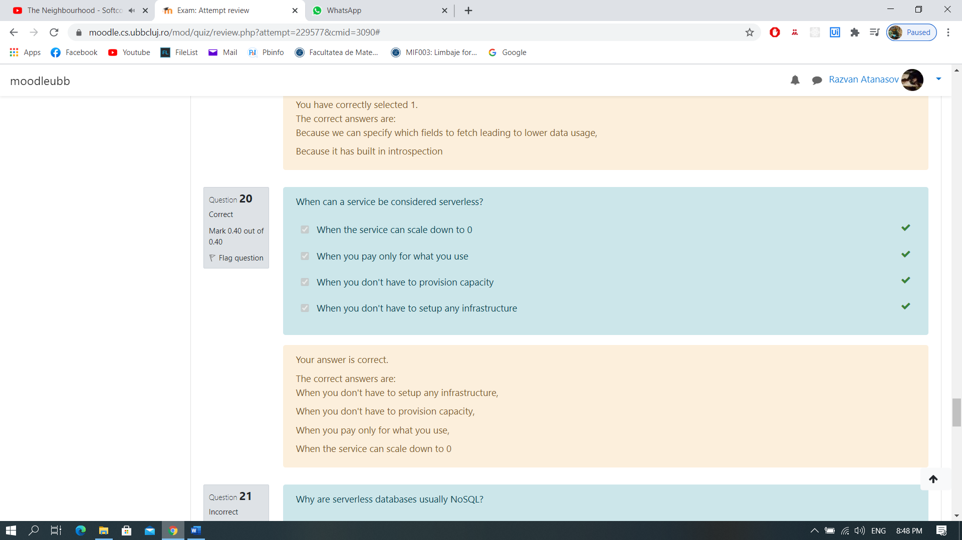
- Why are serverless databases usually noSQL?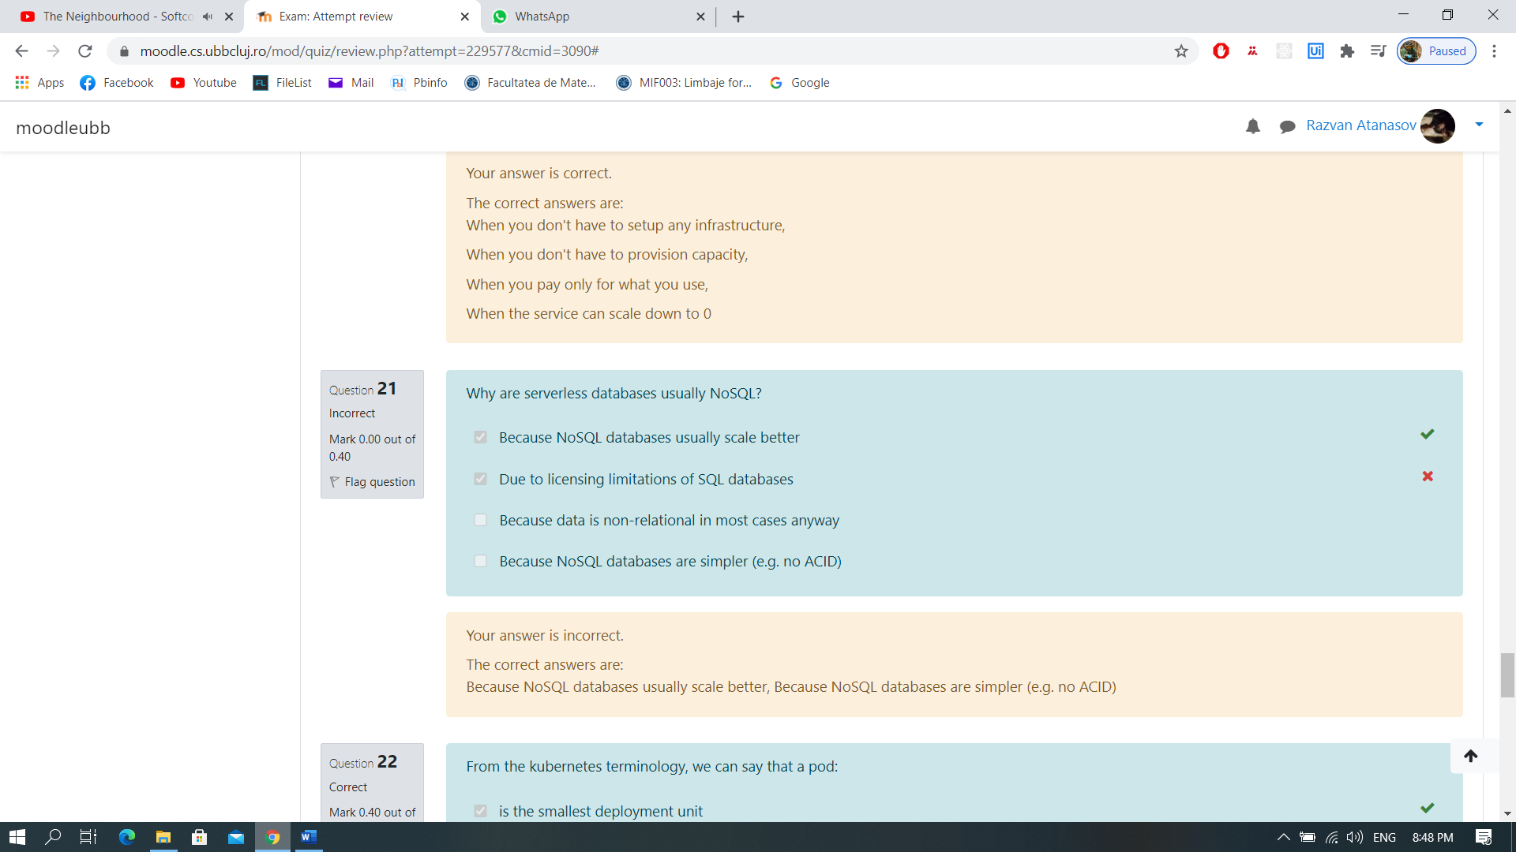
- From the kubernetes terminology, we can say that a pod: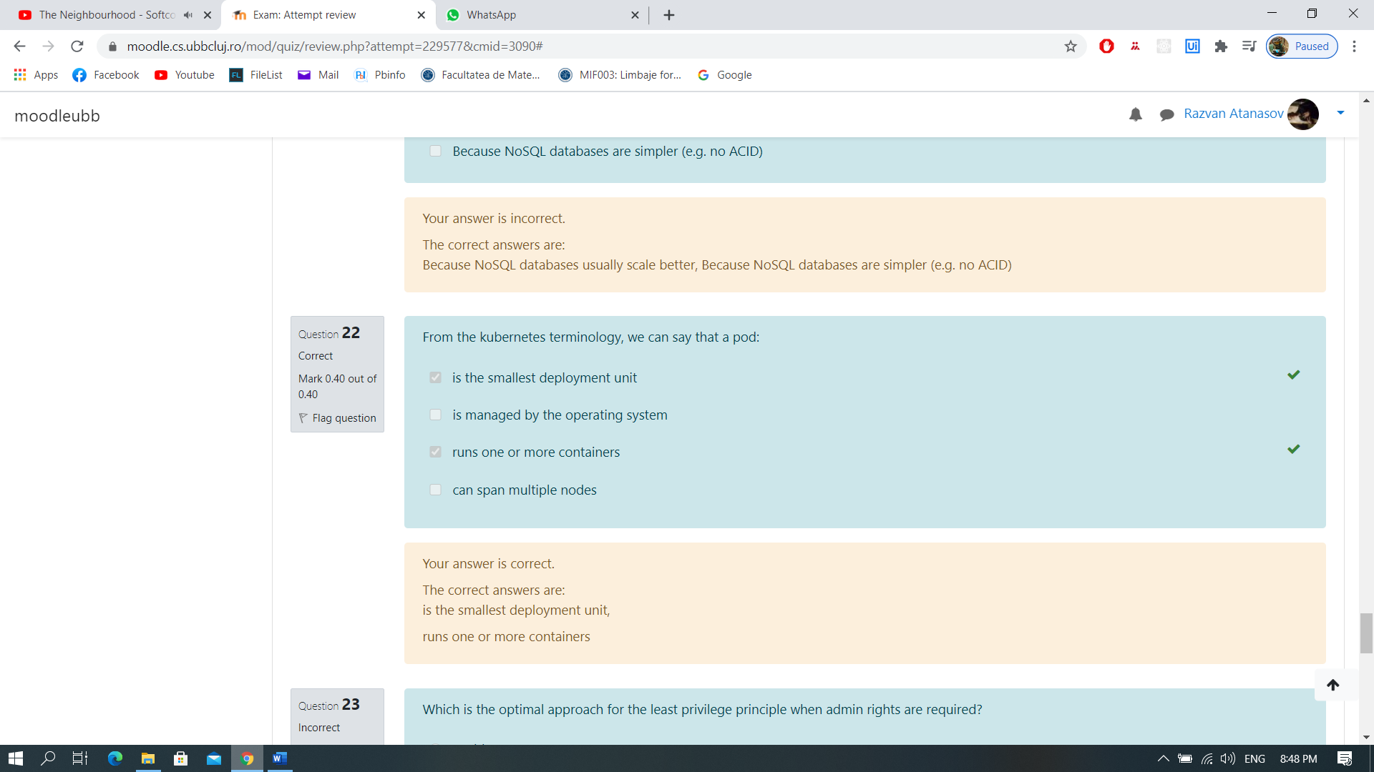
- Which is the optimal approach for the least privilege principle when admin rights are required?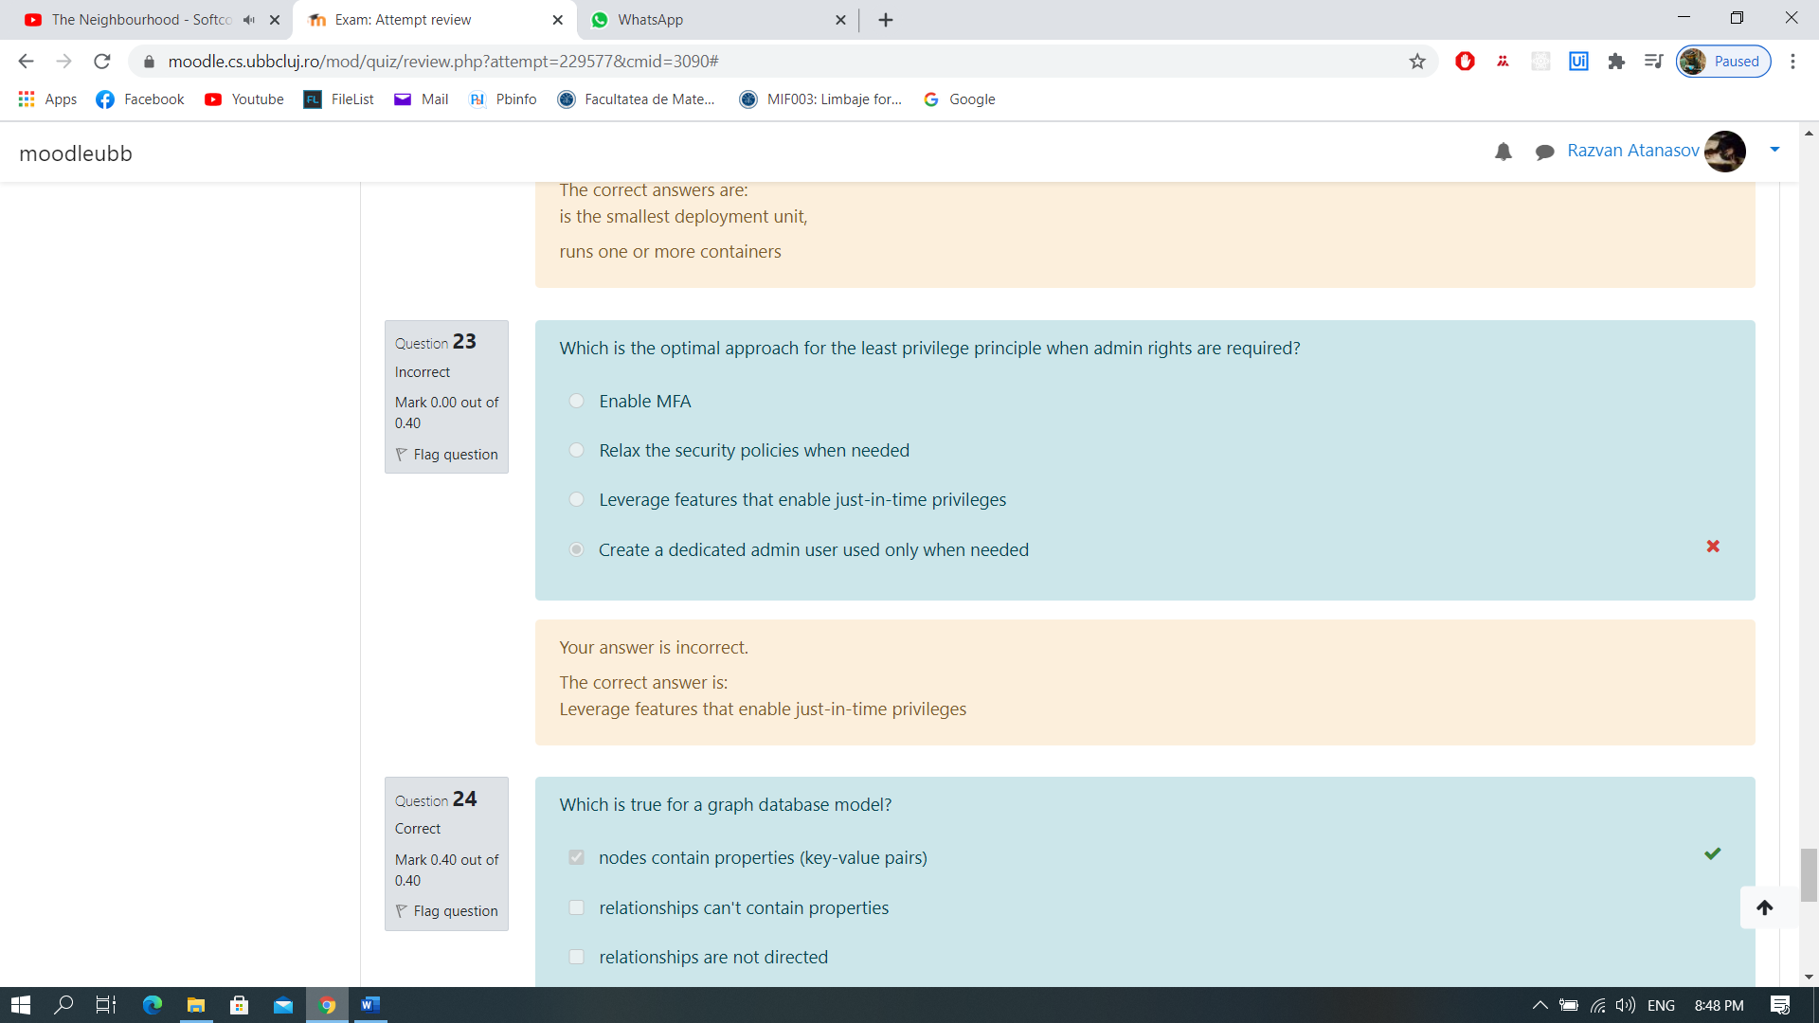
- Which is true for a graph database model?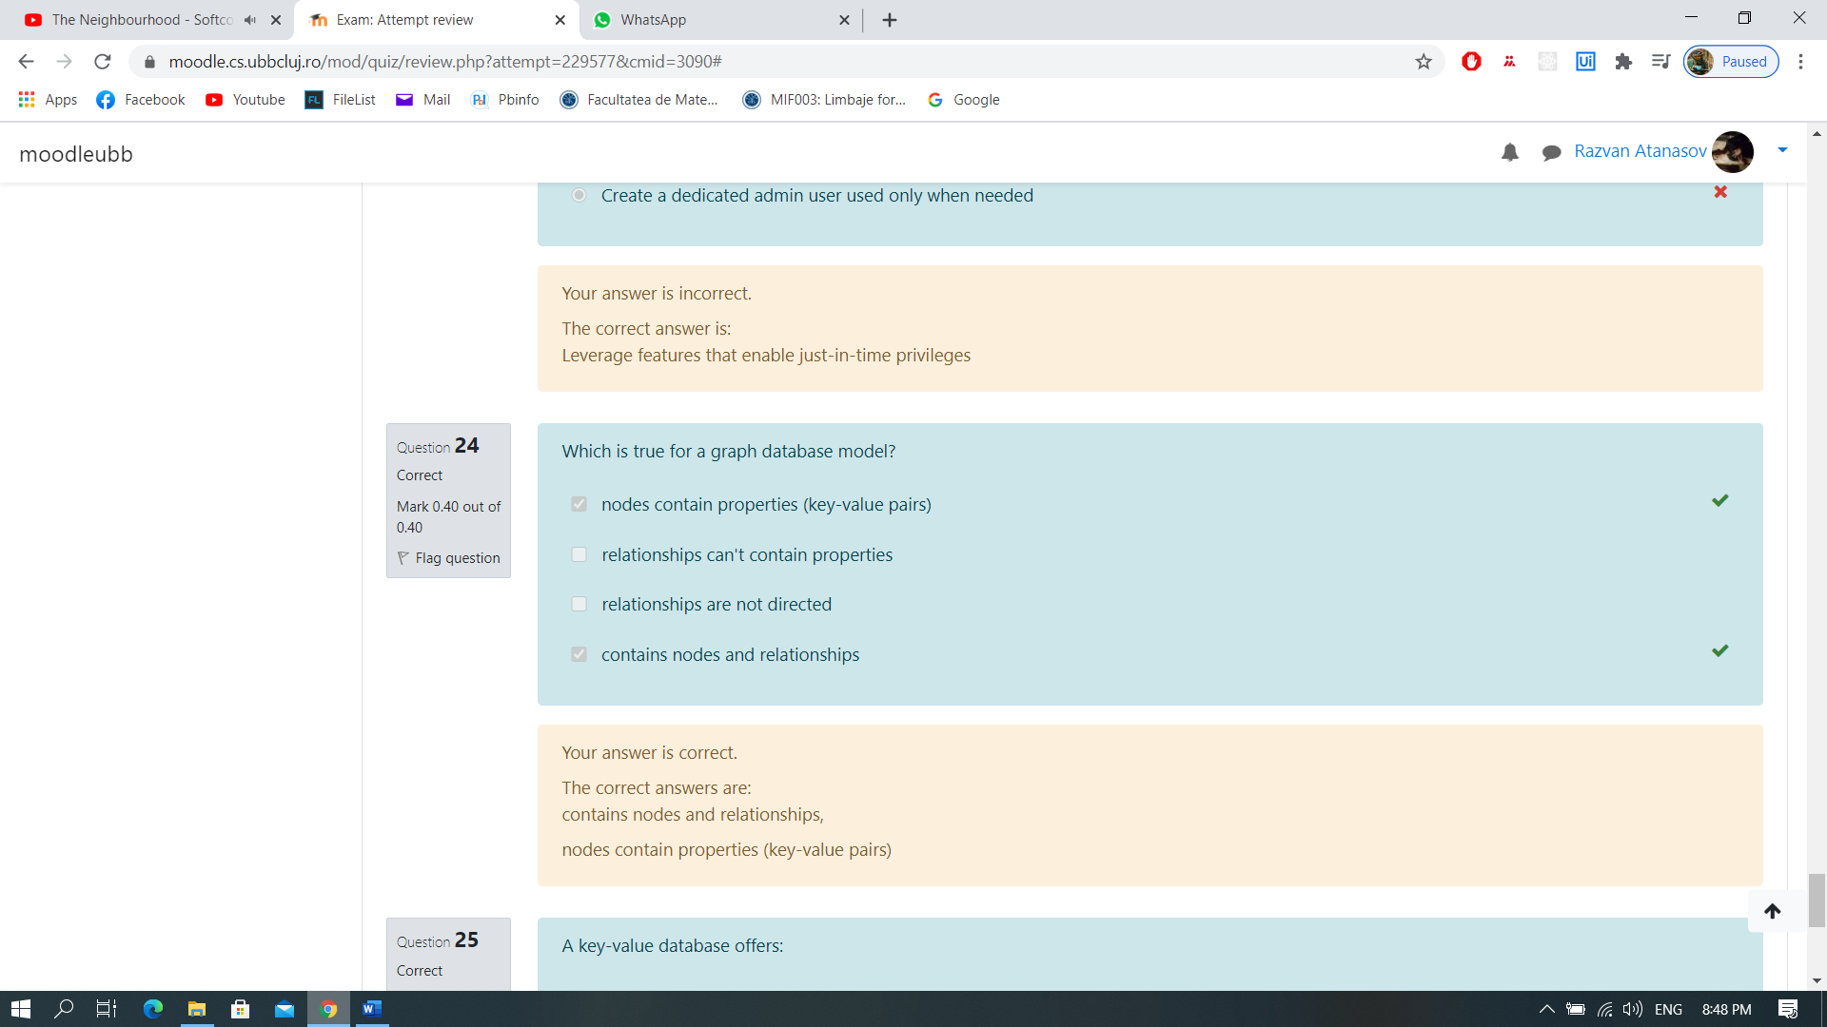

- A key-value database offers: